**Strachey (Giles) Lytton (1880-1932)**

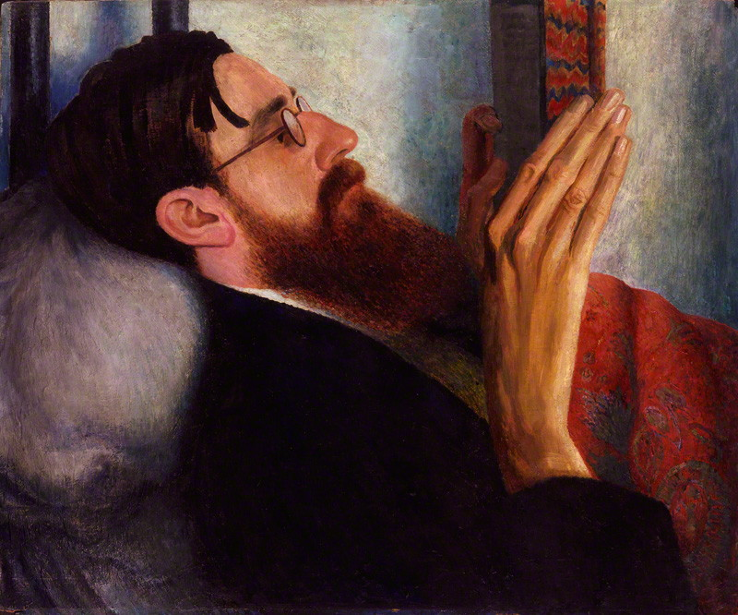**SUMMARY:** Lytton Strachey was an important twentieth-century biographer and literary critic, best known for being a founding member of the highly influential Bloomsbury Group. The group comprised key intellectual and creative figures whose controversial, *avant-garde* work contributed to the modernisation of twentieth-century artistic doctrines. His best-known work, *Eminent Victorians*, published in 1918, helped reinvent life writing as a high literary art. His satirical representations of celebrated Victorians helped to destabilise nineteenth-century values and exposed the hypocrisy of Victorian morality. He identified as a homosexual, openly discussing his beliefs and values with his close circle of friends. This information was not made public until after his death, caused by undiagnosed stomach cancer, at the age of 51. Although overshadowed by his Bloomsbury contemporaries such as Virginia Woolf, he remains a popular and important figure.

Lytton Strachey by Dora Carrington (1916) © National Portrait Gallery, London

**MAIN BODY:**

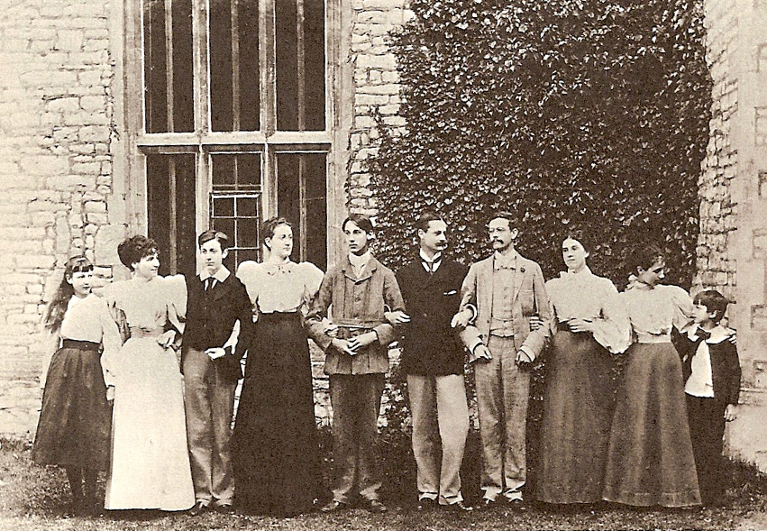Lytton Strachey was born on 1 March 1880. He was one of ten surviving children of the scientist and civil servant, Lieutenant-General Sir Richard Strachey (1817-1908) and his wife, Jane Maria Strachey (1840-1928), a staunch supporter of the women’s suffrage movement. His names Giles and Lytton derived from friends of the Stracheys: the Earls of Lytton – Edward Bulwer Lytton was his godfather. After character building intervals at numerous schools and colleges, documented in a Bloomsbury Memoir Club paper, he embraced his literary identity at Trinity College, Cambridge, where he became friends with other important members of the Bloomsbury group: Leonard Woolf (1880-1969), Clive Bell (1881-1964), John Maynard Keynes (1883-1946) and Thoby Stephen (1880-1906). He studied history, winning a second class honours, a feat considering his regular bouts of ill leave. Strachey considered his years at Cambridge to be happy ones, during which he formed a group called the Midnight Society, seen by members as a preface to the Bloomsbury group, and was elected to the Apostles, the famous undergraduate intellectual society.

Strachey family (Lytton third from left) (wikicommons) [*Lytton Strachey, His Mind and Art (1857)*]

During his time at university and the years after, Strachey produced numerous reviews for magazines. In 1903, he composed a series of review-essays on French and English literature for the *Independent Review*. After failing to win a job at the Education Department of the Civil Service and a fellowship at Trinity College, Strachey returned to London in 1905, where his relationship with Bloomsbury began to blossom. Whilst embarking upon a love affair with his cousin, Duncan Grant (1885-1978), he attempted to earn a living as a literary journalist, writing anonymous poetry and drama reviews for *The Spectator.* In 1910, Strachey believed that he had been offered his big literary break, H. A. L. Fisher, former President of the British Academy commissioning him to write a brief survey of French literature for the Home University Library, *Landmarks of French Literature* (1912). Although it did not furnish him with fame or money, it remains an accessible introduction to the genre, Strachey praising French compositions for their beautiful yet realist characteristics. After his relationship with his cousin fell into disarray – Grant fell in love with Keynes – he began a triangular relationship with Ottoline Morrell and Henry Lamb. It was also during this time that he grew his famous long beard, completing his striking ‘crane-like’ physical appearance that inspired many well-known Bloomsbury portrait painters such as Grant and Vanessa Bell (1897-1961).

After writing some more reviews for the *Edinburgh Review* and *New Statesman*, he began working on some silhouettes of renowned Victorians. As the First World War dawned, he reframed his ideas and began writing his most famous work, *Eminent Victorians* (1918). This satirical biography of four household Victorian names – Cardinal Manning, Florence Nightingale, Thomas Arnold and General Gordon – sought to modernise the literary style of biography, destabilising these Victorian figures by pointing out their damaging moral flaws. Strachey believed that it should be the biographer’s prerogative to document and expose the more human elements of life rather than impose meaning on them: this is elaborated upon further in his manifesto-like preface. Strachey’s groundbreaking, honest criticism made him financially secure for life whilst breaking biography from the realms of patriotism and preservation.

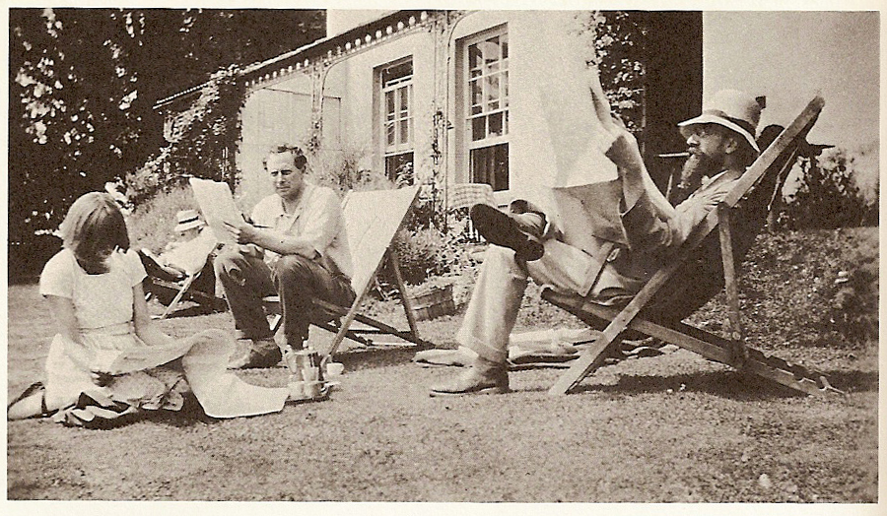 Strachey applied to be a conscientious objector to the First World War but was instead granted exemption on medical grounds. During this time he met Dora Carrington (1893-1932), arguably the most important character in Strachey’s life. They existed happily in a platonic relationship at Mill House, Tidmarth, their love weathering the vast array of destructive affairs they both embarked upon. Eventually Strachey, Carrington and her husband, Richard Partridge, moved to Ham Spray House in 1924, where he would live out the rest of his life.

Dora Carrington, Ralph Partridge and Lytton Strachey at Ham Spray House (wikicommons) [*Lytton Strachey, His Mind and Art (1857)*]

After *Eminent Victorians*, Strachey began working on a new biography of the best-known Victorian of all: *Queen Victoria* (1922). The work was milder in tone, but still strived to deconstruct patriotism and celebrity to make room for the more liberating elements of character. Victoria was presented to the public in a new light, as a child, as a lover, as a domestic figure and (humorously) as a strong-willed, female tyrant. In the same year, Strachey also collated a sample of reviews and essays written over the previous two decades, publishing the collection as *Books and Characters* (1922).

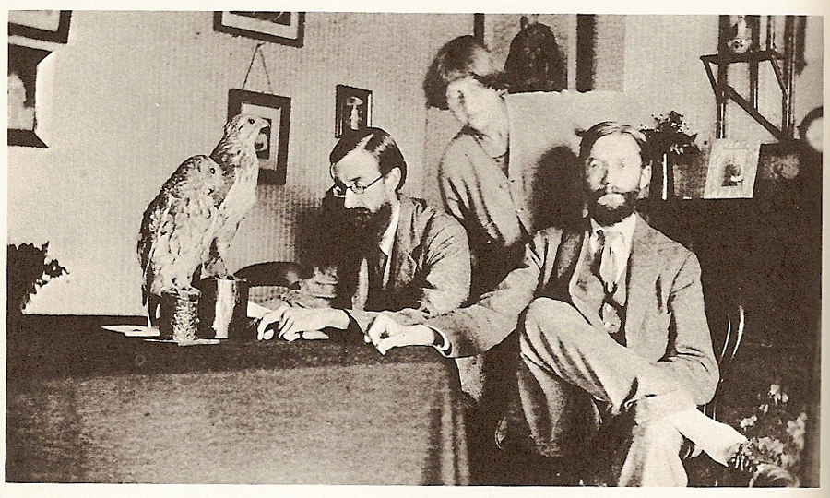 His next work, and last full-length biography, *Elizabeth and Essex* (1928), incorporated fact and fiction, the work concentrating on one episode of Elizabeth I’s life and using poetic licence to explore her relationship with a young earl. Drawing from his own selfhood, and influenced by Freud’s investigation of the Queen’s sexuality, the book problematised the boundaries of truth and the imagination, poetic license intricately woven with the more factual, historical elements that underpin the biographical genre. Strachey’s fellow writer and Bloomsbury member, E. M. Forster called this work his masterpiece. The last of Strachey’s published works – aside from the posthumous biographical snippets, essays and articles that were published – was *Portraits in Miniature and Other Essays* (1931), which brought together a variety of essays that he had written for the *New Statesman, Nation* and *Life and Letters.* Strachey also integrated some of his best brief lives.

On 21 January 1932, Strachey died of undiagnosed stomach cancer. Seven weeks later, Carrington shot herself, unable to cope with her platonic partner’s departure. Strachey’s contributions to biography and literary criticism soon faded out of the public eye, although his memory and reputation were upheld by the Bloomsbury set. As literary executor, his brother, James Strachey, continued to publish his essays. A generation later, Michael Holroyd’s edited biography of Strachey, written by himself, (1967-68) helped reestablish him in the public consciousness, and, following this, numerous publications regarding his life, letters, works (and his cinematic portrayal by Jonathan Price in the film *Carrington*) have followed his legacy through into the twenty-first century.

Lytton Strachey, Dora Carrington and James Strachey (wikicommons) [*Lytton Strachey, His Mind and Art (1857)*]

**List of Works:**

*Landmarks in French Literature* (1912)

*Eminent Victorians: Cardinal Manning, Florence Nightingale, Dr Arnold, General Gordon* (1918)

*Queen Victoria* (1921)

*Books and Characters* (1922)

*Elizabeth and Essex: A Tragic History* (1928)

*Portraits in Miniature and Other Essays* (1931)

**Posthumous Works:**

*Characters and Commentaries*, ed. James Strachey (1933)

*Spectatorial Essays*, ed. James Strachey (1964)

*Ermyntrude and Esmeralda*, (1969)

*Lytton Strachey by Himself: A Self-Portrait*, ed. Michael Holroyd (1967-8, revised 1971)

*The Really Interesting Question, and Other Papers*, ed. Paul Levy (1972)

*The Shorter Strachey*, ed. Michael Holroyd and Paul Levy (1980)

*The Letters of Lytton Strachey*, ed. Paul Levy (2005)

*Unpublished Works of Lytton Strachey: Early Papers*, ed. Todd Avery (2011)